**Environment:** Analysis was performed on TEST environment.

General info:

|  |  |  |  |  |  |
| --- | --- | --- | --- | --- | --- |
|  | **Host** | **Type** | **IP** | **Hosted Applications** | **Ports** |
| STAGING | EPUAKYIW1686T1 | VM | 10.17.172.226 | EPUAKYIW1686T1.kyiv.epam.com | 8080, 4444 |

System resources (TEST env):

|  |  |  |
| --- | --- | --- |
| **CPU, GHz** | **Memory, Gb** | **Disk size, Gb** |
| 2 | 8 | 100 |

**Test scenario**

There are considered Main script for Anonymous user scenario for two type of probability usage where

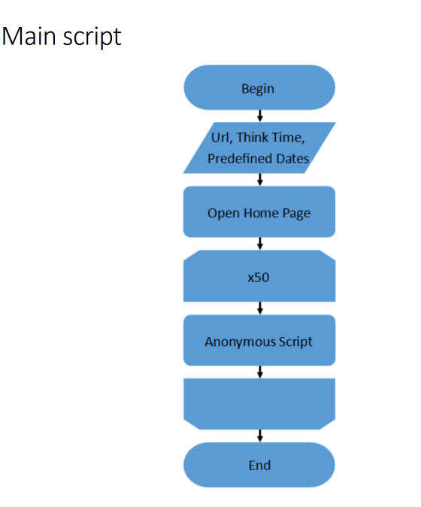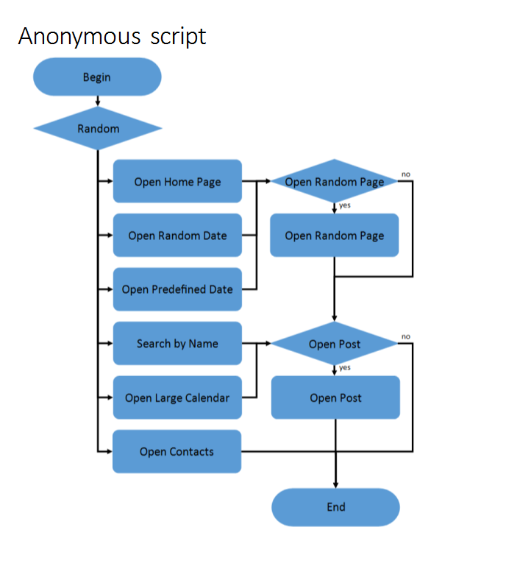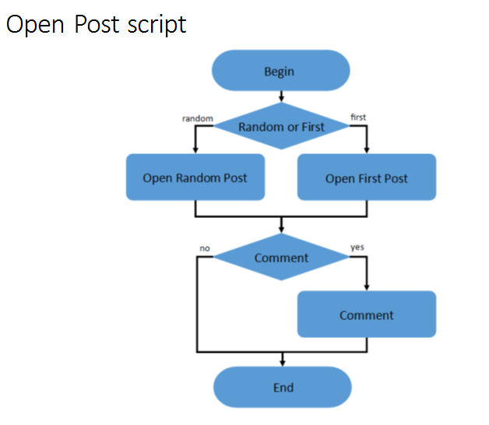

**Test conditions**

|  |  |
| --- | --- |
| **Transaction** | **Condition** |
| open home page | 15% |
| open random date | 10% |
| open predefined date | 30% |
| search by name | 30% |
| open large calendar | 10% |
| open contacts | 5% |
| open random page | 50% |
| open post | 80% |
| open random post | 65% |
| open first post | 35% |
| add comment | 20% |

**Test Setup**

|  |  |
| --- | --- |
|  | Condition |
| number of virtual users | Up to 150 |
| ramp-up period(sec) | 750 |
| duration(sec) | 900 |
| think time (sec) | 3-5 |

**Test Summary(100 vs 1000 posts for conditions)**

1 The maximum capacity of the application usage by Anonymous clients is found. For both scenarios it is restricted by the 100% CPU usage and and a significant increase in the use of network resources. Adding more load leads to the application becomes unresponsive.

2 Saturation point is 132 users for the 1st scenario(100 posts). Saturation point is 86(1000 posts) for the 2nd scenario.

3 A memory leak was possible.

**Recommendation**

1 Possibility to increasing CPU power.

2 Increase Network I/O.

3 After reaching the point of saturation, the application doesn't respond and no recovery is provided for. Perhaps we should add a recovery step or at least a stub which produced 500 errors.

4 Due to the use of probable percentages in the second case the load was greater and more real. A memory leak was possible, needed to set a limit on the number of requests for an open predefined date, search by name, open post and increase network resources.

5 Until the time of increasing resources, it is better to limit the number of posts.

**Results: graphs and tables(1-st and 2-nd scenario, for more details open dashboard HTMLReport > index)**

1 Statistics

1-st scenario 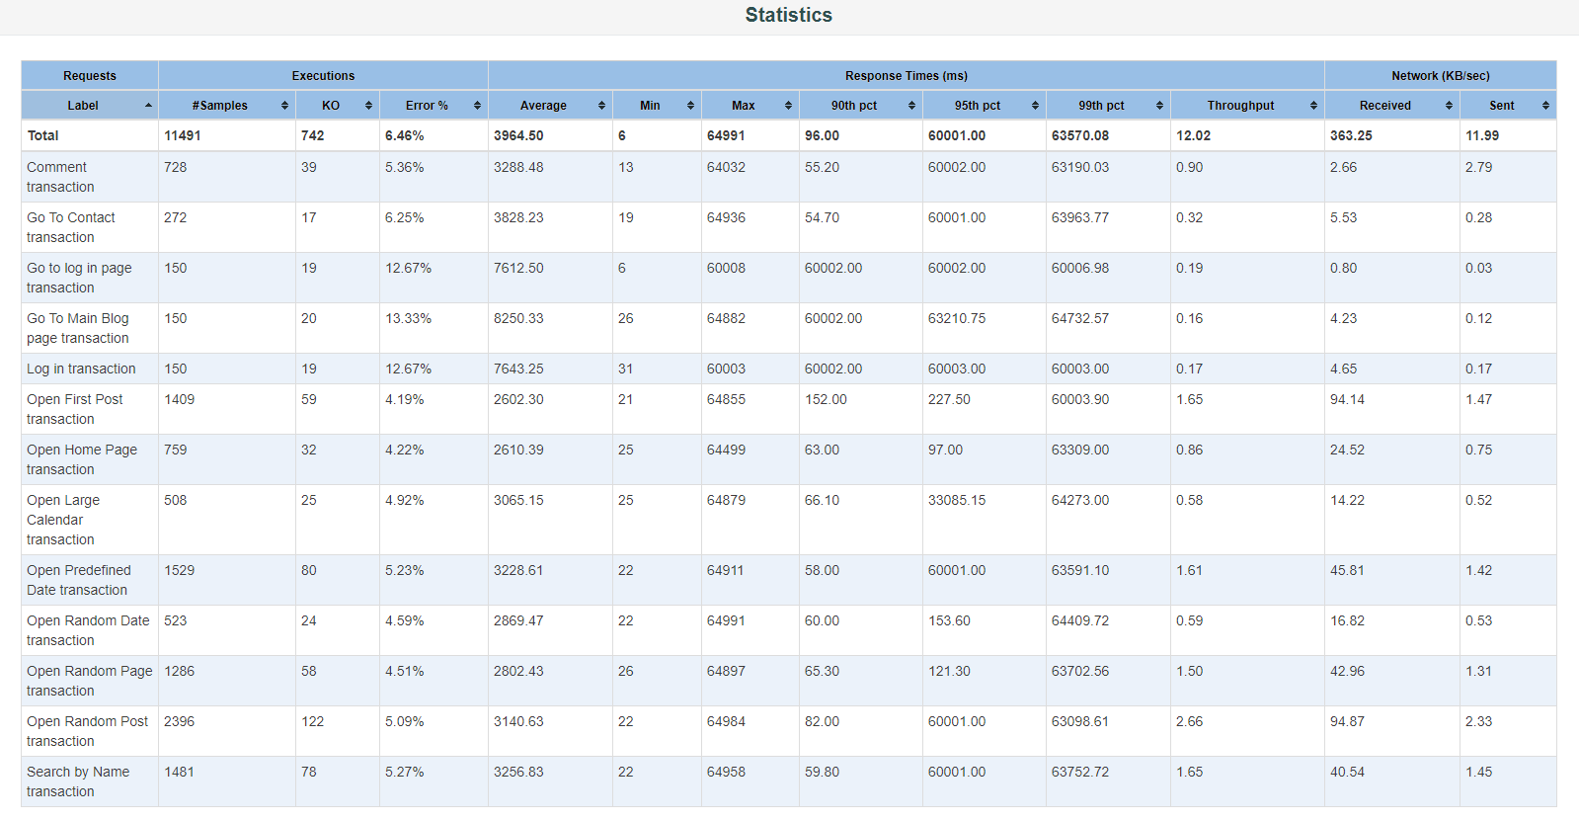

2-nd scenario

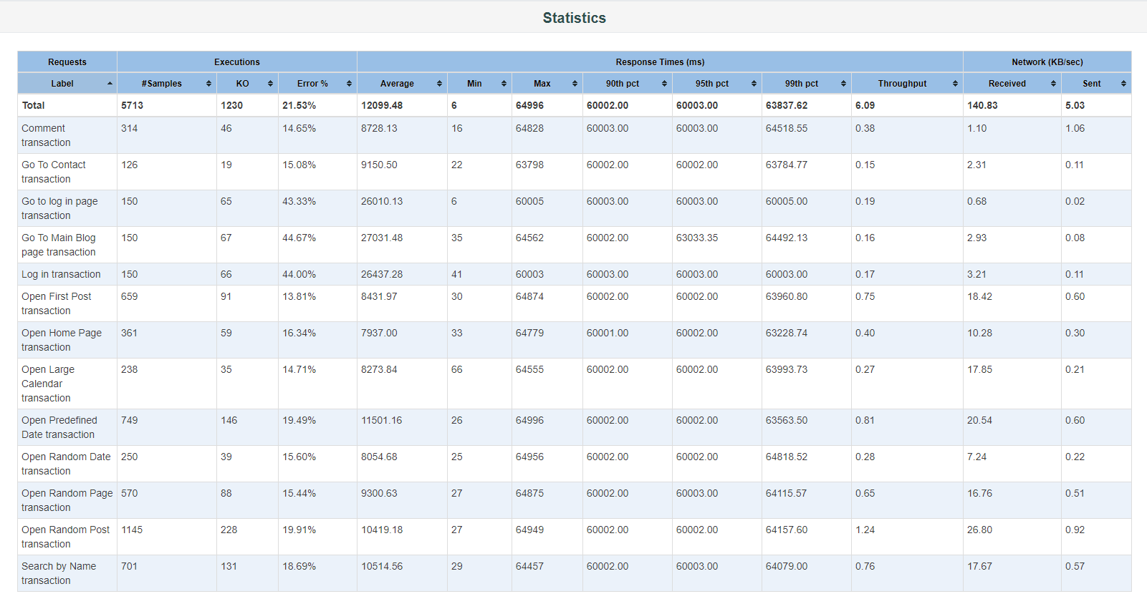

2 Number of active threads graph

1-st scenario

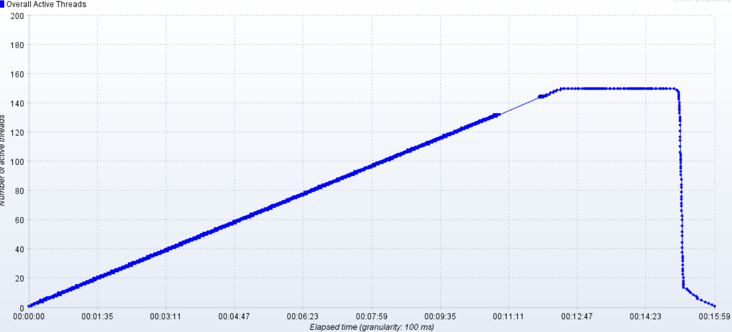

2-nd scenario

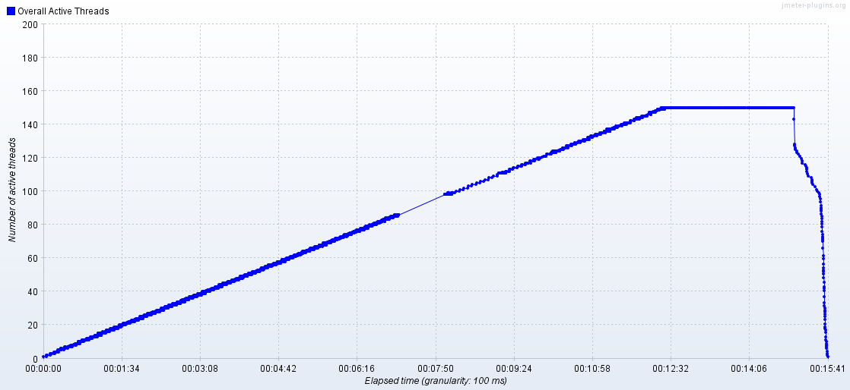

3 PerfMon Metrics (CPU,Memory,Network) graphs

1-st scenario

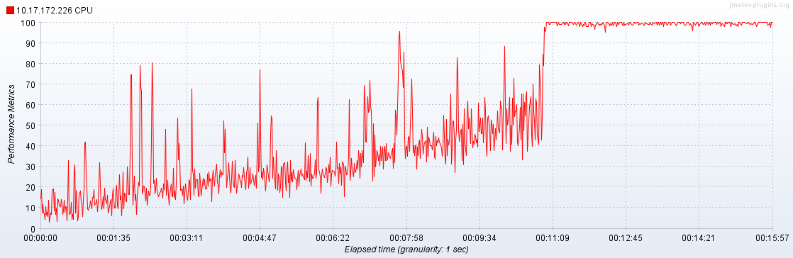

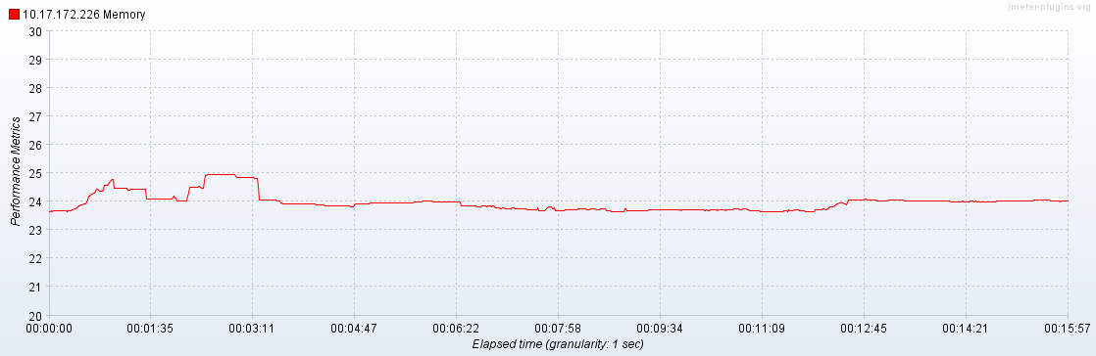

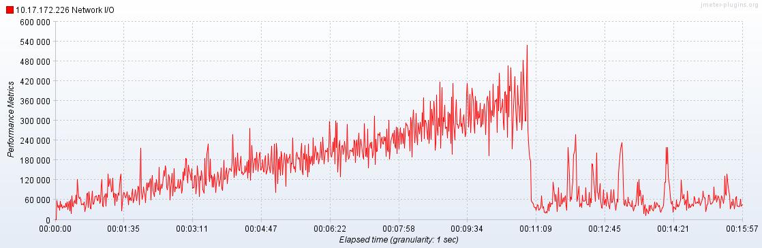

2-nd scenario

